**Snowflake Architecture: Storage, Compute, and Cloud Services:**

This document provides a comprehensive technical analysis of the Snowflake cloud data platform's unique architecture. Unlike traditional databases that tightly couple storage and compute, Snowflake employs a revolutionary multi-cluster, shared data architecture that separates these three core functions: **Storage**, **Compute**, and **Cloud Services**. This separation is the foundational principle behind Snowflake's performance, scalability, and simplicity. This documentation delves into each layer, explaining its role, components, and interaction with the others, supported by a conceptual architecture diagram.

**Objectives**

The primary objectives of this documentation are to:

* **Articulate** the core components of Snowflake's three-layer architecture.
* **Explain** the technical benefits of decoupling storage from compute.
* **Detail** the function and interaction of the Database Storage, Query Processing, and Cloud Services layers.
* **Demonstrate** how this architecture is implemented in a practical scenario.
* **Highlight** the tangible results and business benefits derived from this design, such as concurrency, scalability, and ease of use.

**System Design: Snowflake's Multi-Cluster, Shared Data Architecture**

At the heart of Snowflake is its patent-pending architecture that physically separates but logically integrates its core functions. This design eliminates the resource contention and management complexities found in traditional data warehouses.

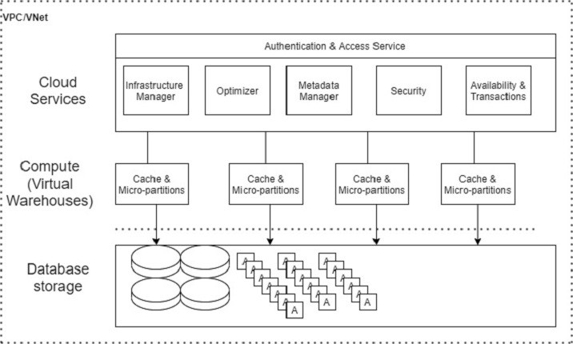

The Database Storage layer is the foundational layer where all structured and semi-structured data (JSON, Avro, Parquet, etc.) is stored.

* **Function:** This layer is responsible for the permanent, secure, and highly durable storage of all data loaded into Snowflake.
* **Technical Details:**
  + **Format:** Snowflake automatically manages the internal organization, structure, and file format of stored data. Data is stored in a proprietary, optimized, compressed, columnar format.
  + **Location:** The storage is implemented and managed within the customer's cloud provider account (AWS S3, Azure Blob Storage, or Google Cloud Storage) but is accessible only through Snowflake's SQL interface.
  + **Object Abstraction:** Users interact with data through familiar relational database concepts like tables and schemas, without needing to manage the underlying cloud storage objects (files, buckets, or containers).
* **Key Characteristic:** **Shared Data.** Since storage is decoupled from compute, this single, central copy of data can be concurrently accessed by an unlimited number of independent compute resources without creating data silos or copies.

**Query Processing (Compute)**

The Query Processing layer is where all SQL execution and data processing tasks occur. This is handled by **Virtual Warehouses**.

* **Function:** Virtual Warehouses are Massively Parallel Processing (MPP) compute clusters composed of multiple nodes (CPU and memory) from the underlying cloud provider. They execute operations such as queries, data loading, and unloading.
* **Technical Details:**
  + **Independence:** Each virtual warehouse is independent and does not share compute resources with others, ensuring workload isolation and performance predictability.
  + **Elasticity & Scalability:** Warehouses can be resized (scaling up) or started/stopped (scaling out) on-demand or automatically. This allows users to right-size compute resources for their specific workload, from a small X-Small warehouse to a multi-cluster, massive warehouse.
  + **Multi-Cluster Warehouses:** For high-concurrency scenarios, a multi-cluster warehouse can be configured. This automatically starts, stops, and load-balances queries across multiple clusters to handle a large number of concurrent users without queueing.

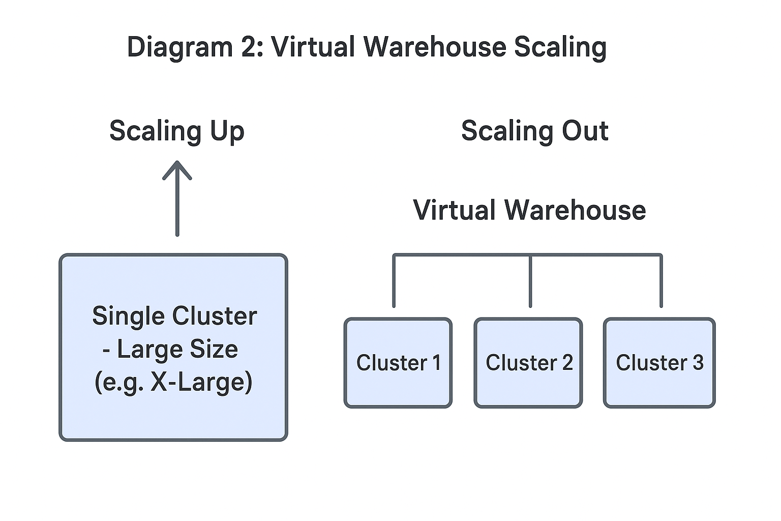**Cloud Services**

The Cloud Services layer is the brain of the Snowflake architecture, a globally distributed service that coordinates and manages all activities across the platform.

* **Function:** This layer is a collection of services that tie together the storage and compute layers. It requires no management and is billed on a per-use basis.
* **Key Services Include:**
  + **Authentication & Access Control:** Manages user login and security policies.
  + **Infrastructure Manager:** Handles the provisioning, management, and destruction of virtual warehouses.
  + **Query Optimizer:** Parses and optimizes SQL queries before assigning them to a virtual warehouse for execution. It does not perform the actual computation.
  + **Transaction Manager:** Provides full ACID (Atomicity, Consistency, Isolation, Durability) compliance for all data transactions.
  + **Metadata Management:** Tracks all metadata, including statistics about tables, schemas, and micro-partitions (Snowflake's internal storage unit).

**Implementation: A Practical Walkthrough**

This section outlines a typical workflow to demonstrate how the three layers interact.

**Data Loading and Storage**

1. A user executes a COPY INTO command to load data from a cloud storage stage.
2. The **Cloud Services** layer receives the request, validates permissions, and coordinates the process.
3. A **Virtual Warehouse (Compute)** is assigned to read the files from the external stage.
4. The warehouse compresses, partitions the data into micro-partitions, and writes it to the **Database Storage** layer.
5. The metadata for the new data (row count, file references, etc.) is recorded by the **Cloud Services** layer.

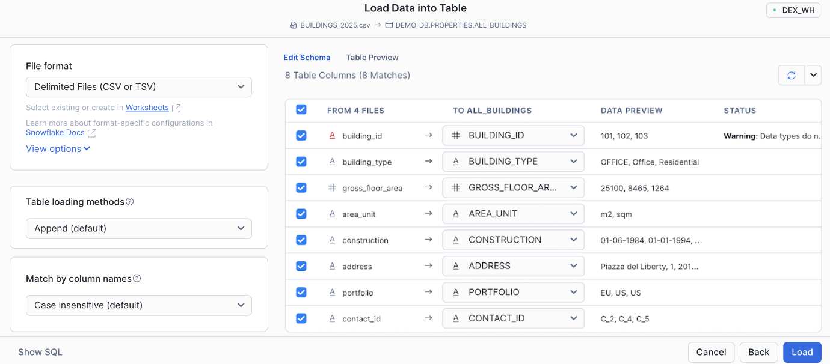**Configuring Virtual Warehouses for Compute**

1. A data analyst runs a complex multi-table JOIN query.
2. The **Cloud Services** optimizer parses the query and develops an optimized execution plan.
3. The plan is dispatched to a designated **Virtual Warehouse**.
4. The warehouse spins up (if it was suspended), reads *only the relevant micro-partitions* from the **Database Storage** layer (a process called **pruning**), and executes the query in parallel across all its nodes.
5. The result is returned to the user, and the warehouse can be configured to auto-suspend to save costs.

**Leveraging Cloud Services**

1. A user logs into the Snowflake web interface. This authentication is handled by the **Cloud Services** layer.
2. The user browses the Object Explorer to see tables and views. This metadata is served instantly by **Cloud Services** without needing to start a virtual warehouse, a feature known as **Zero-Copy Cloning**.
3. The user creates a clone of a database for testing. This operation is near-instant and is managed entirely by **Cloud Services**, which simply creates new metadata pointers to the existing storage.